*Software Requirements*

*Specification*

*–*

**Author(s): AruneshanS**

**Date: February** 22,2023

**Confidential 1**



**Copyright notice:** Copyright © 1996-2004 Aspire Systems. All rights reserved. The contents on this document are not to be reproduced or duplicated in any form or kind, either in part or full, without written consent from Aspire Systems.

Contents

### Abstract 3

### Modules 3

* 1. HomePage 3
  2. Product3
  3. Registration

### Error! Bookmark not defined.

1. Functional Requirements 4
   1. Time Management 4
   2. Attendance Management………………………………………………………………………………………………….4
   3. Login/Sign-up 5
   4. Scheduling…………………………………………………………………………………………………………………………….5
2. Non – Functional Requirements 5
3. High-Level Design 6
4. Low-Level Design 9

### Use Case Diagram…………………………………………………………………………………………..10

### Class Diagram ……………………………………………………………………………………………………………………………………………......11

### Sequence Diagram ……………………………………………………………………………………………………………………………............................................................12

### Flow Chart…………………………………………………………………………………………. ………………..13

### ER Diagram…………………………………………………………………………………………………… 14

1. **Abstract**

Our Project **Timesheet management system** is a web application developed using ASP.NET programming platform. The main aim of this project is to help software companies and other enterprises to complete tasks in a given time. With a timesheet management system, managers and employees can study work progress reports on a daily basis and analyze the time available to complete the given task or project.

The Timesheet Management System allows employees to work on client’s requirements and projects on a day to day basis. Timesheets may record the start and end time of tasks or just the duration. It may contain a detailed breakdown of tasks accomplished throughout the project or program. This data is used for payroll, client billing, billable and non-billable project costing, analysis, tracking, and management. Employees fill timesheets on a daily , weekly and monthly basis. Employees will be able to easily find out what they need to be tracking, as well as prioritizing their tasks so that the most time-sensitive ones can be done first. Basically, it allows employees to work on the go and let them clock in and clock out on their mobile devices, or even at home. Timesheets being used to do this means that you can configure it any way you want in order to suit the requirements of your business.

It has mainly Three modules. One is at Administration Level , other one is at User Level and third one is at Manager level . The Application maintains authentication in order to access the application. Administrator tasks include managing Employees information, keeping Records of leave, team members, status reports, Task information and Payroll etc. The User Level helps in checking the status of work, updating, deleting, applying for leave and View reports. This System is used to record and track how much time each employee takes to complete his task. It helps in tracking the Current status of the task. Time management broadly includes,

Timesheet management involves these operations such as new, submitting, revoking, approval and rejection. Generating, appropriate reports on time spent details

1. **Modules**
   1. **Home Page**

The application starts with the Homepage and this page gives the user an overview of application is about. At the top of the homepage application, you can see the “sign-in/sign-up” tabs. So, if you the user wants to view the task assigned by the manager they can just click on the tab and it will take them to a page that contains task information such as assigned time, completed time, permissions and, etc. At the same point, the admin can also have an option of assigning new task to the dashboard or directly assign them and update it . The homepage also allows the user to directly login/sign-up. Other than these functionalities, the homepage also contains small snippets of information about the online application.

* 1. **Employee module**

The key features included under this module are employee change, enter timesheet, edit timesheet, update timesheet, view timesheet and delete timesheet. This module is handled by the employees.

The employeecan view his progress in the task and track how much he spend time in completing his task.

* 1. **Admin Module**

This module is handled by the administrators. It provides admins the features such as adding new projects and viewing timesheet of all projects. The forms in this module are adding, billing, pro billing, approve action, update and view project.

* 1. **Sign-in/Sign-up**

So now the user can login/sign-up from the login page. Now if the user already has an account they can directly login. Otherwise, they will have to create an account by signing up. The user just has to enter the username, email id, password. Then the admin would validate the data and if the data provided by the user is valid, then it will be stored in the database and the user’s account has been created.

* 1. **Manager Module**

This module is handled by the company managers; this allows the managers to view employee time sheets and releases. The key features here are allocate, change password, release and update.

# Functional Requirements

Functional requirements are **the desired operations of a program, or system as defined in software development and systems engineering**. The systems in systems engineering can be either software electronic hardware or combination of software-driven electronics.

* 1. **Time Management:**

Time management helps in keep track of the time it takes to complete tasks and submit. It can periodically update on request from admin and user. It helps to manage time for work and progress.

## Attendance Management

It keeps track of a person's attendance in the organization, also it can keep track whether he is ontime or late. Attendance management features support flexible workplace structures through enhancements, such as automated timesheets.

## Login/Sign-up

To Access the Time sheet, the user should either have an account or create one. The user can login/sign-up from the registration page. Now if the user already has an account they can directly login. Otherwise, they will have to create an account by signing up. Now as you can see in the images under High level design. There is Login-in page and just below that, there is a link which says “Sign-up”. As mentioned before, if you don’t have an account, all you need to do is click on the link and it will render a new registration page and in the registration page you will have to enter the information. One thing you will notice in the Sign-up page is that the conditions have been stated and if those conditions haven’t been met, the you will not be allowed to submit.

## Scheduling:

Scheduling streamlines the schedule creation process with collaborative features, providing automated tools that considers shift preferences and other parameters. The software serves as a centralized location for employees to view schedules, make requests and notify others of any changes. Some programs even provide remote access, two-way calendars and reporting components to boost compliance.

# Non – Functional Requirements

* 1. **Reusable code**

Reusable code should always be a key factor that needs to be considered. The code should be reusable because it reduces the time it takes to develop application. The code should also have the ability to build larger things from smaller parts

* 1. **Efficient**

The code should not only be reusable but also extremely efficient. Since we are using react JS, the code will be efficient. React JS is know for being very efficient because with minimal programming a lot can be created.

In react JS, a copy of the DOM is used. In other word, the usage of virtual DOM will occur which is the copy of real DOM. Since, we are using virtual DOM (Document Object Module), react JS in general is lightweight.

**4.4** **User friendly**

The web application should be user friendly as it is one of the most important factors. If it is not user friendly the users would not want to comeback. Everything should be available to the user and the user should not be looking for anything. For example, if the user is looking for a particular product, but the product is not available, under that image of the product, it should be displayed saying the product is out of stock. So, basically whenever the user logs into this web application, the customer should have a very smooth experience.

# High-Level Design

* The Homepage will give the user a gist of what this online website is. It will contain small snippets of information about the website and a few features such as scheduling, time management that are for sale will be displayed.
* At the top of the Homepage, there will be a login bar and it will redirect to login page and the page will consist of username and password options.
* The login/sign-up button will always be at the top.
  1. **Homepage**

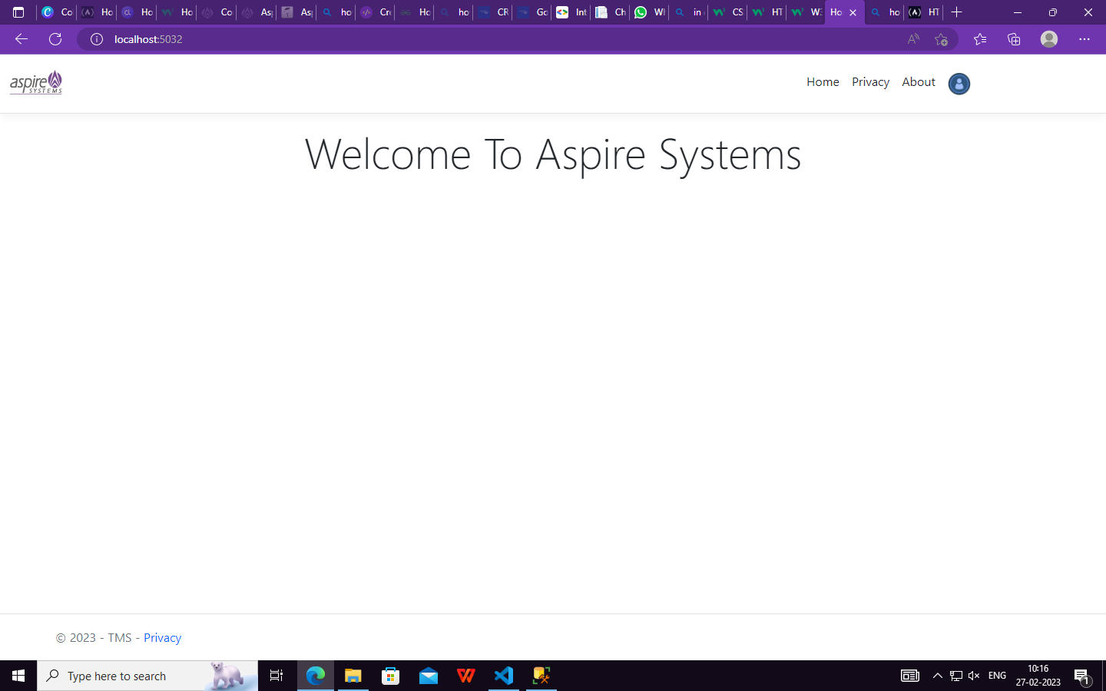

* 1. **Login-in Page**

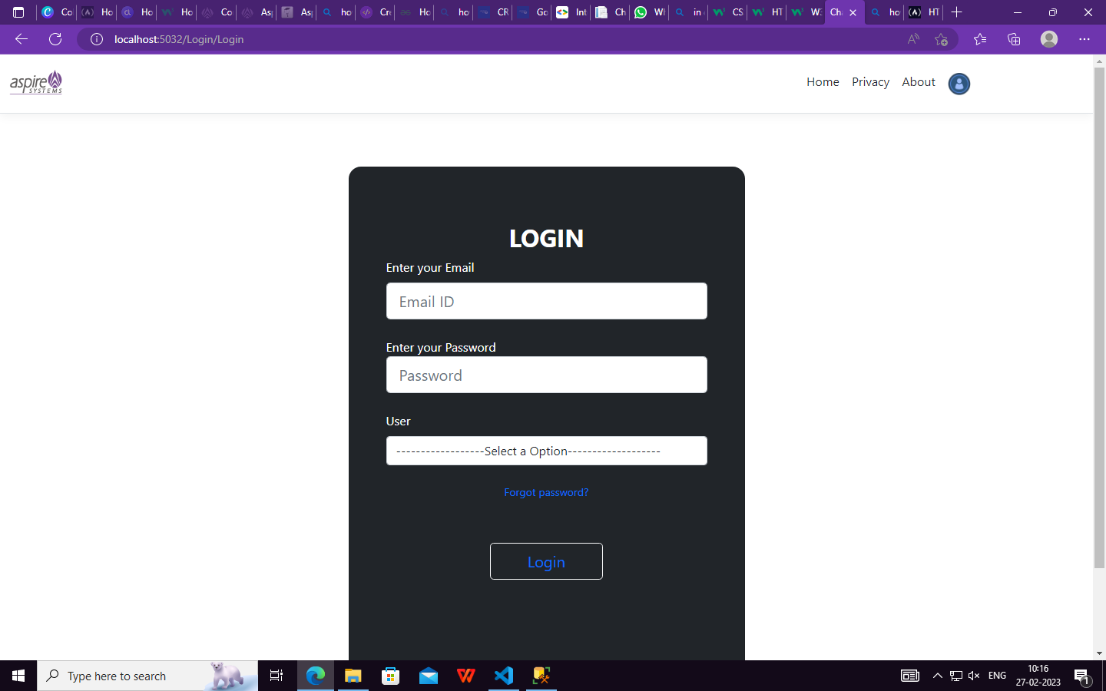

**5.3 DashBoard**

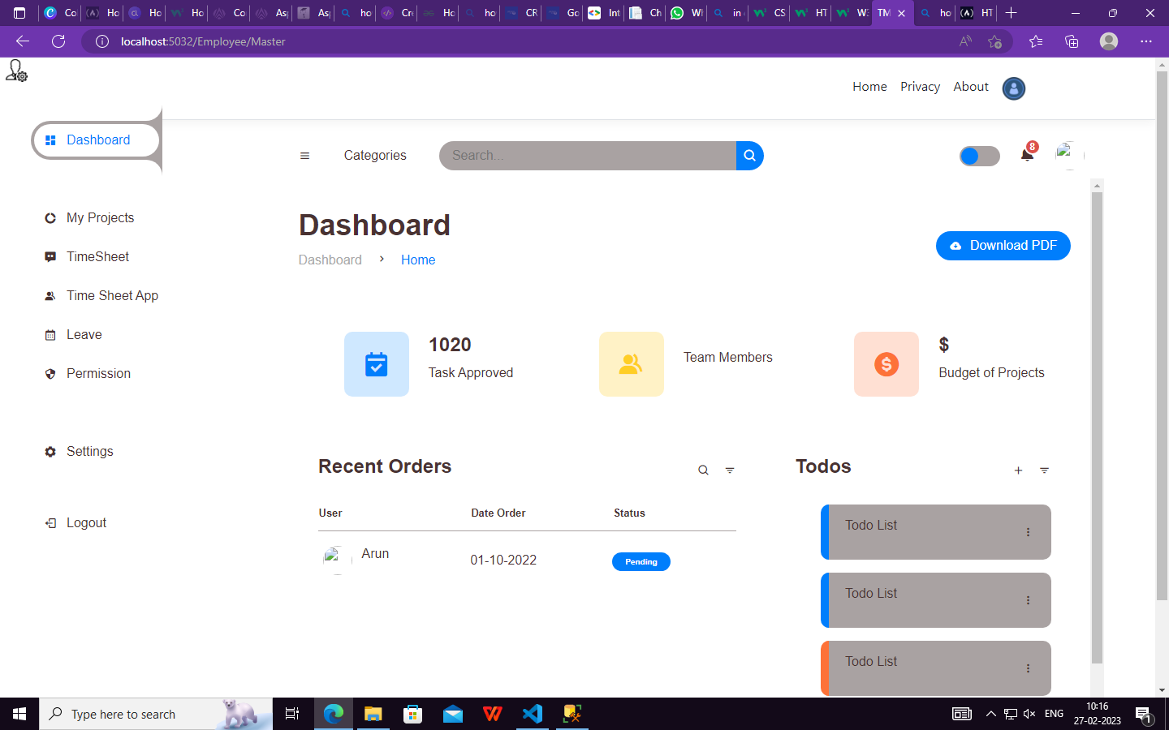

# Low-Level Design

* The small snippets of information on the homepage are the type of navigation bar options and the number of products being sold and when the shopping website was established.
* When employee details are displayed, the information that will be provided are, the image of the, the name, the price of the product, and the specifications of the task.

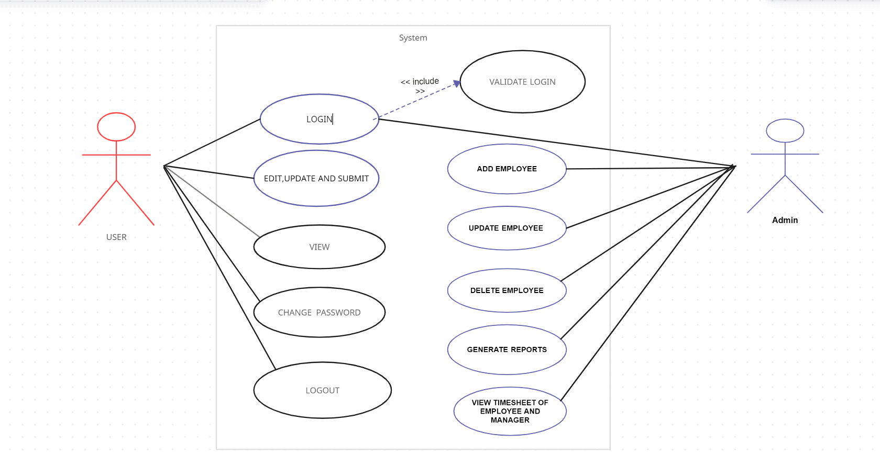

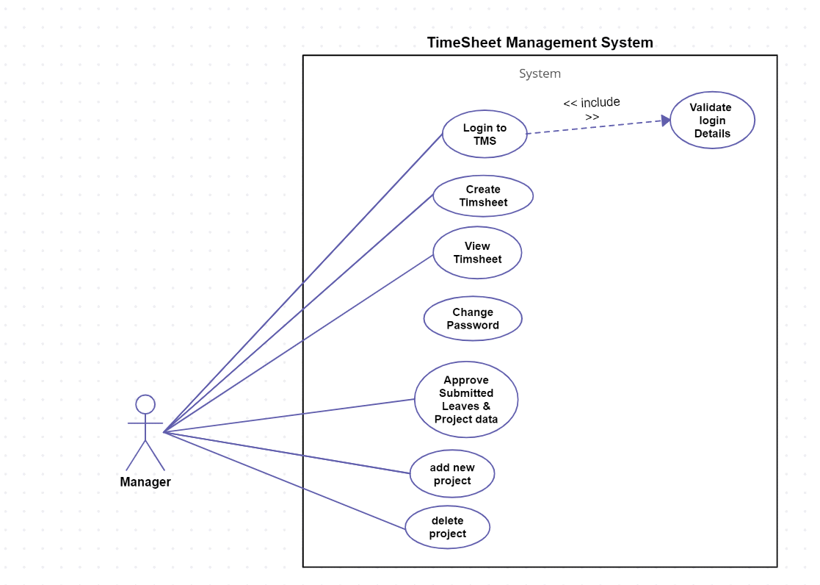

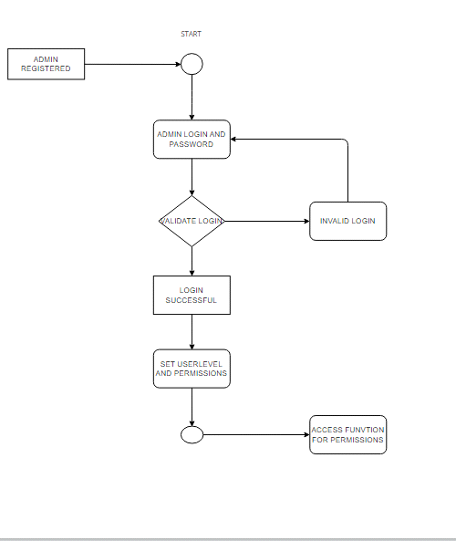

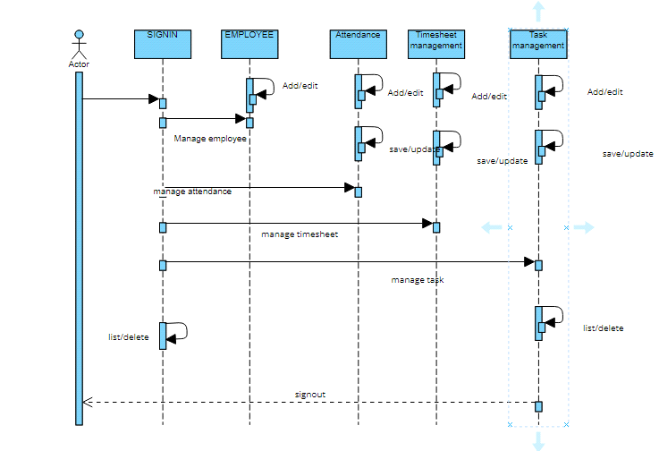

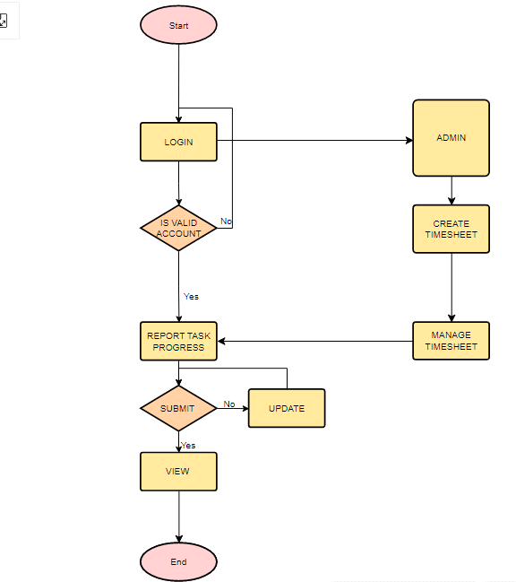

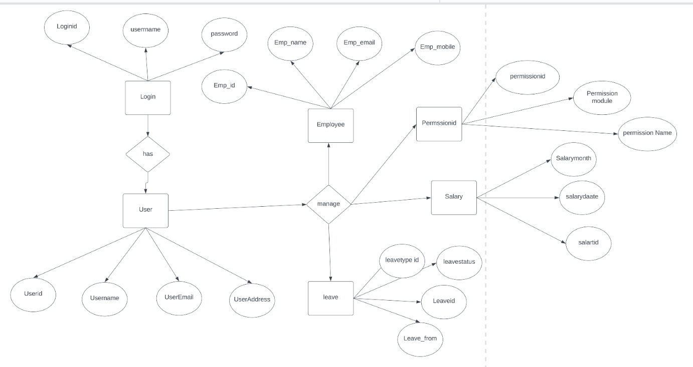

1. **Class Diagram**

